Modern Girl Fashion
Student’s Name
Institution
Date

Modern Girl Fashion
- What makes the Modern Girl “modern”? How is this relevant today?
Modern girl has become modern through the development of public image, sexuality, and fashion. She expresses herself through recognizing international trends that exist within society. The fashions that most women practice in their lives have increased their beauty and self-esteem. In current times, women can make themselves beautiful through the use of beauty makeups. Also, the modern woman has the chance of expressing themselves in the geopolitical structures. Femininity in the current times has motivated women to reveal their cultural flows. Womanhood gets promoted in many forms to ensure their representations to get developed within different countries.
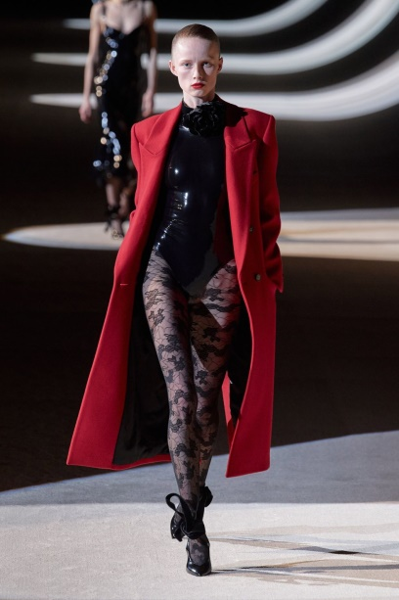
Figure 1: International fashion trends
- What “bundle of commodities” deUine the modern girl? Is the bundle different today?
Modern girls get described through commodities that include globalization, modernity, and consumption ("Every Look from Fendi Spring/Summer 2021," 2020). These commodities have made sure that modern girls have the confidence to express themselves without any form of control. The bundles still exist in the current world because globalization has ensured the transfer of cultures to other countries. A modern girl can, therefore, purchase beauty makeups that get applied to their bodies. Feminism has ensured modern girl to express herself and achieve her expectations. The beauty of modern girls is the main goal achieved by using the commodities of globalization and consumption.
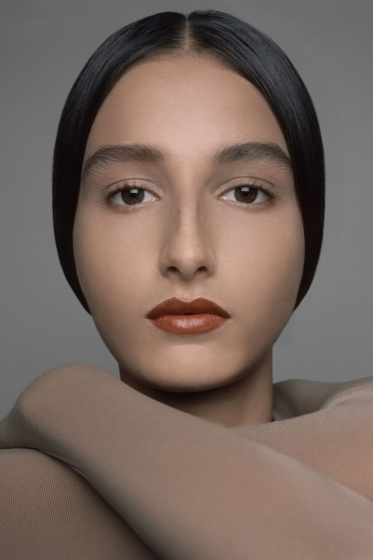
Figure 2: Make-up application
- Is the idea of “technologies of the self” still relevant or has it changed?
The technology of self still exists because it gets promoted through the innovative volume of creating collaboration. The technology of self has made it possible for women to develop their public image. Technologies of self still form the main basis for existence in women's lives when expressing their sexuality and fashion. The use of global trends that depict provocative and interesting body structures still exists in modern times. Women express their sexuality that gets regarded as the technology of the self. Women transform their bodies in certain ways that make them feel happy and achieve a quality life. The transformation has also been done on their minds, souls, and lifestyle.
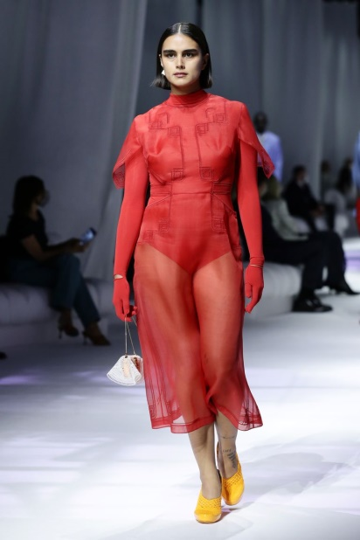
Figure 3:Lifestyle transformation
- What is the connection between the “modern girl”, ideal beauty and race?
The modern girl has deployed a lot of their energies in increasing their beauty within society. The process has made modern girls from different races to get viewed differently. In Africa, modern girls get accused of performing prostitution because of imitating white culture. The beautification that African ladies get done has made them get judged harshly by their fellow men. In westernized countries, the use of cosmetics gets encouraged in women's lives to help increase their beauty ("Face Forward: Navigating Pandemic Makeup," 2020). Increased use of cosmetics is regarded as an appropriate method of beauty promotion.
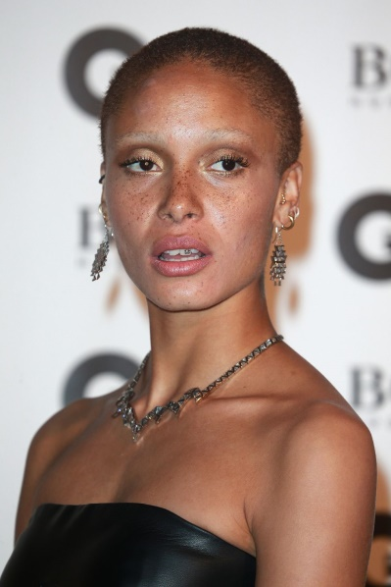
Figure 4: Beautification in Black ladies
- Identify exemplars of today’s modern girl.
Today's modern girl is one who knows how to take charge of her own life in society. For instance, lady feminists are today modern girls who confidently perform what their identities conform to ease. The activities that lead to creating real-life amongst superwomen ensure they express what they need to accomplish in their lives (Weinbaum Et al. 2008). Ladies who fight for equality in all genders tend to practice what makes them feel happy without getting restricted. The existence of female feminists in most countries has ensured modern girls perform anything they like. Women can apply makeup to ensure their beauty gets increased.

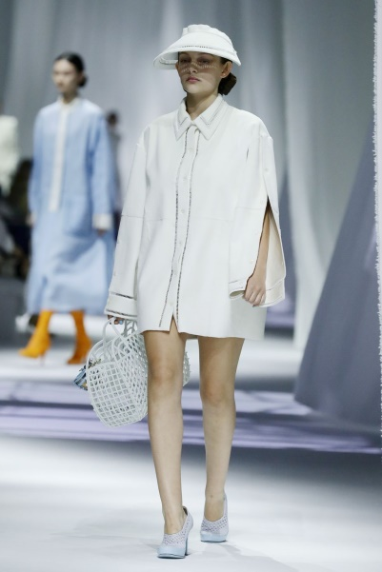
Figure 5: Fashionable feminism

References
Every Look From Fendi Spring/Summer 2021. (2020, September 23). CR Fashion Book. Retrieved November 5, 2020, from https://www.crfashionbook.com/fashion/g34055019/fendi-springsummer-2021-runway/?slide=4
Face Forward: Navigating Pandemic Makeup. (2020, October 17). CR Fashion Book. Retrieved November 5, 2020, from https://www.crfashionbook.com/beauty/a34403611/face-forward-navigating-pandemic-makeup/

